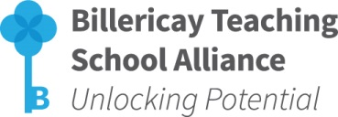
NATIONAL PROFESSIONAL QUALIFICATION
for MIDDLE LEADERSHIP (NPQML)
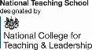

Venue: Mayflower High School, Stock Road, Billericay, CM12 0RT
Time & Date: 9:30-4:00pm, 16th Oct 2018,
2:30-5:30pm, 20th Nov 2018, 21st Jan 2019, 12th Mar 2019 & 3rd June 2019
Cost: £975 per delegate
We are able to offer fully-funded places on the NPQs to those applicants working in a school in an Opportunity Area (OA), see here or a Category 5 or 6 area, see here.
BOOKING FORM

School: |  | Headteacher:
School Tel. No: |  | Headteacher Email Address:
Participant Details: (one booking form per participant)
Name: | Position in School | Email Address
Special Requirements (dietary/mobility etc):
Sponsor Details: (this should be a Senior Leader, or Headteacher)
Name: | Position in School | Email Address
School CPD Leader Details:
Name: |  | Email Address:
Contact Details for Invoicing purposes:
Name: |  | Email Address:

To secure a place on this programme, please complete this Booking Form and return via email to: mjones@billericayschool.com

- Places will be allocated on a first come/first served basis
- Confirmation will be sent via email
- Further details will be sent prior to the start of the programme
- If for any reason the booking has to be cancelled, a refund will only be issued if the place can be filled

For further information please contact: Mel Jones, Billericay TSA Administrator, The Billericay School, School Road, Billericay, Essex, CM12 9LH T: 01277 314420 E: mjones@billericayschool.com

