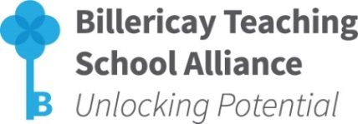
The Power of Coaching
for Team, Middle and Senior Leaders



(Primary & Secondary)

Venue: Sunnymede Junior School, The Meadoway, Billericay, Essex, CM11 2HL
Date/Time: 2 afternoon sessions (1:00pm to 5:45pm)
14 & 23 November 2017
Cost: £200 per delegate
BOOKING FORM

School:
Headteacher:
Headteacher Email Address:
Delegate Details: (Please insert additional rows as necessary)
Name: | Contact Tel No. | Email Address
Special Requirements (dietary/mobility etc):
School CPD Leader Details:
Name: |  | Email Address:
Contact Details for Invoicing purposes:
Name: |  | Email Address:

To secure a place on this programme, please complete this Booking Form and return via email to: mjones@billericay.essex.sch.uk

- Places will be allocated on a first come/first served basis
- Confirmation will be sent via email
- Further details will be sent prior to the start of the programme
- If for any reason the booking has to be cancelled, a refund will only be issued if the place can be filled

For further information please contact: Mel Jones, Billericay TSA Administrator, The Billericay School, School Road, Billericay, Essex, CM12 9LH T: 01277 314420 E: mjones@billericay.essex.sch.uk

